Working With Multiple Requirements

* ASP.Net Core improved support for controlling application behaviour across multiple environments such as development,staging and production.
* Environment Variables are used to indicate which environment the application is running in, allowing the app to be configured appropriately.

Development , Staging and Production

* ASP.Net core references a particular environmental variable ASPNETCORE_ENVIRONMENT to describe the environment.
* This variable can take 3 Values

1. Development
2. Staging
3. Production

* This environment should be configured to maximize security, performance and application robustness.

1. Turn On Caching
2. Ensure client side resources are bundled and minified.
3. Turn on diagnostic Error Pages
4. Turn on friendly Error pages
5. Enable Production logging and monitoring

Setting the environment

1. Right click on Project and go to debug section where you can set the environments

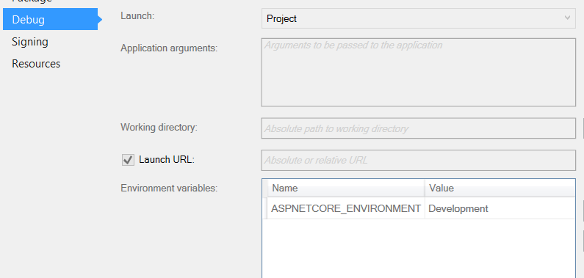

1. When you change this , it makes changes in launchSettings.json

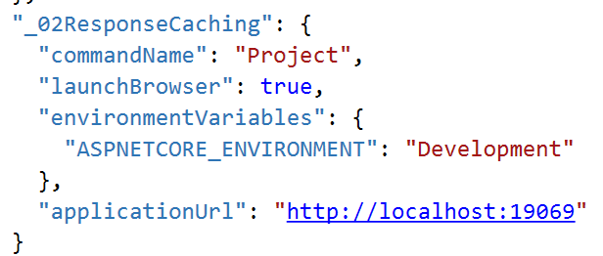

1. Set the Development environment Options

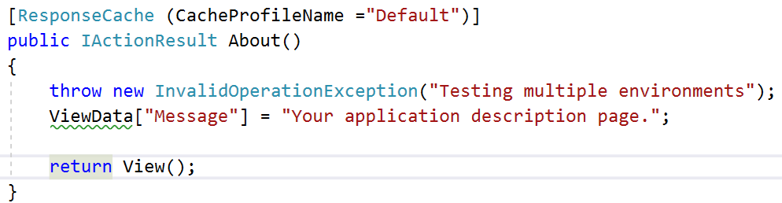

1. Now if you hit this page it will show debugging page

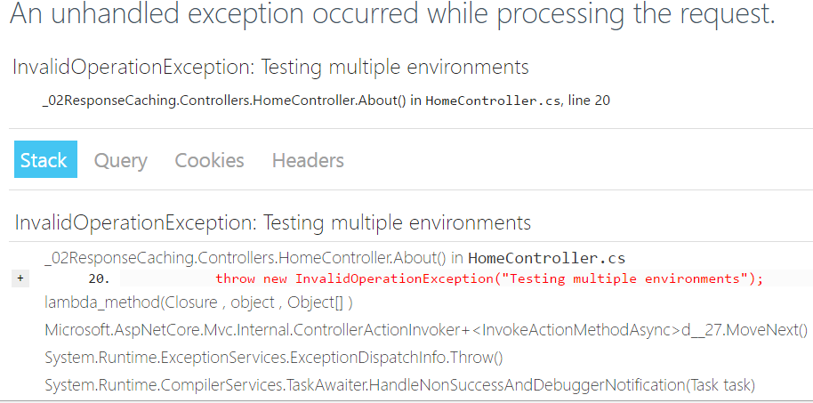

1. Change it to Production

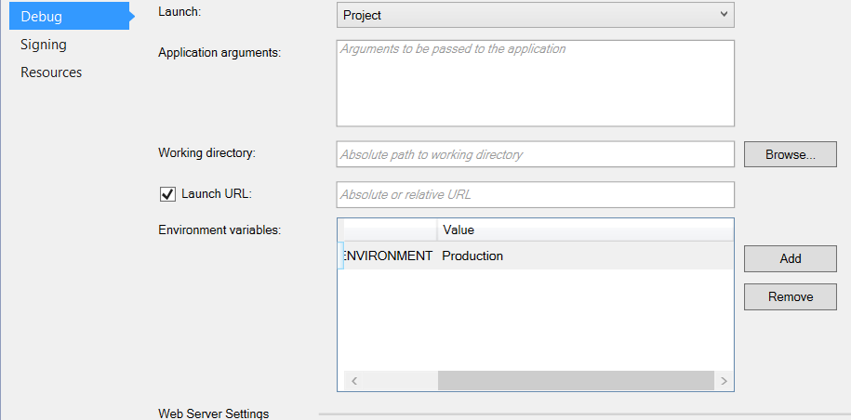

1. Now run the same application .

